Day 3 Ram And Storage
1:- Create a comparison table listing the main differences between DDR3, DDR4, and DDR5 RAM, including speed, voltage, and typical use cases.
RAM (Random Access Memory) is temporary memory used by a computer to store data and instructions that are currently being used by the CPU. DDR (Double Data Rate) is a type of RAM technology. DDR3, DDR4, and DDR5 are different generations of this technology, with each newer generation generally providing higher data-transfer rates and improved power efficiency.
What is DDR?
DDR stands for Double Data Rate.
DDR is a type of SDRAM (Synchronous Dynamic Random-Access Memory) technology used in a computer's RAM.
The term “Double Data Rate” means that DDR memory can transfer data twice during each clock cycle—once on the rising edge and once on the falling edge of the clock signal. This allows it to transfer data faster than older memory technologies that transfer data only once per clock cycle.
DDR Generations
DDR memory has developed through several generations:
DDR → DDR2 → DDR3 → DDR4 → DDR5
With each generation, improvements were made mainly in:
- Data-transfer speed
- Power efficiency
- Memory capacity
- Overall memory performance
DDR (Double Data Rate) is a type of SDRAM technology used in computers for RAM. It transfers data twice per clock cycle, providing faster data transfer. DDR has different generations such as DDR3, DDR4, and DDR5, with newer generations generally offering higher speeds and better power efficiency.
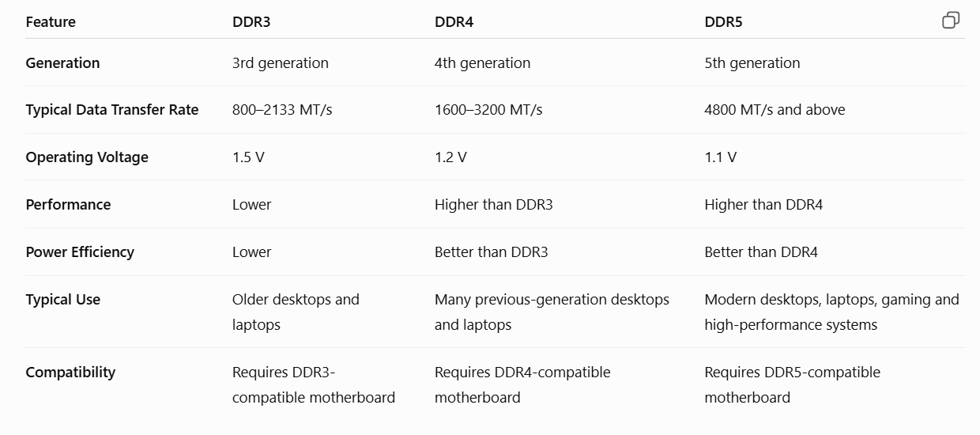
- Speed: DDR5 offers significantly higher data-transfer rates than DDR4 and DDR3.
- Voltage: DDR5 operates at a lower standard voltage (1.1 V) than DDR4 (1.2 V) and DDR3 (1.5 V), improving power efficiency.
- Use cases: DDR3 is mainly found in older systems, DDR4 is common in many previous-generation systems, while DDR5 is used in newer computers requiring higher memory performance.
Conclusion
DDR5 is the latest of the three generations and provides higher data-transfer rates, improved efficiency, and greater memory scalability compared with DDR3 and DDR4. However, DDR3, DDR4, and DDR5 are not interchangeable because each requires a compatible motherboard and memory slot.

2.Open your laptop or desktop (with power disconnected), locate the RAM slots, and take a clear photo of the installed RAM module. Reinstall the RAM module and verify that your system boots up successfully.<br><br><em><strong>Hint:</strong> Refer to your device manual or a trusted YouTube guide if unsure about RAM removal and installation steps.</em>
Installed RAM module before removal.
RAM module removed from the motherboard slot.
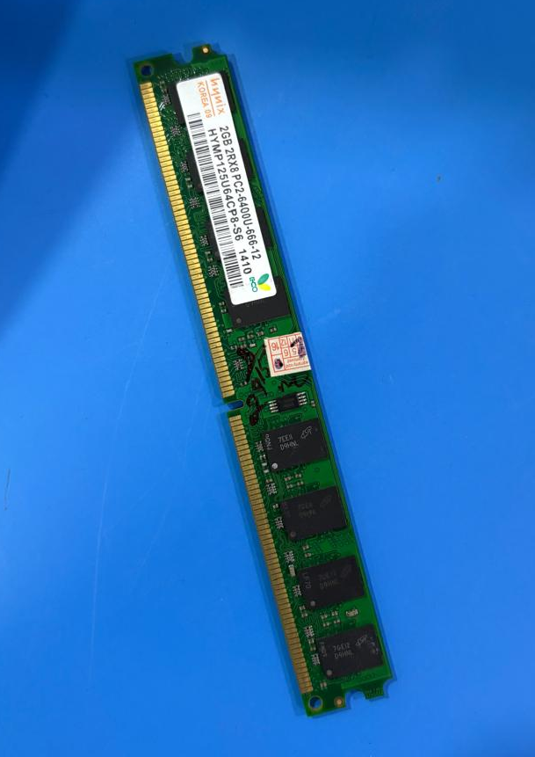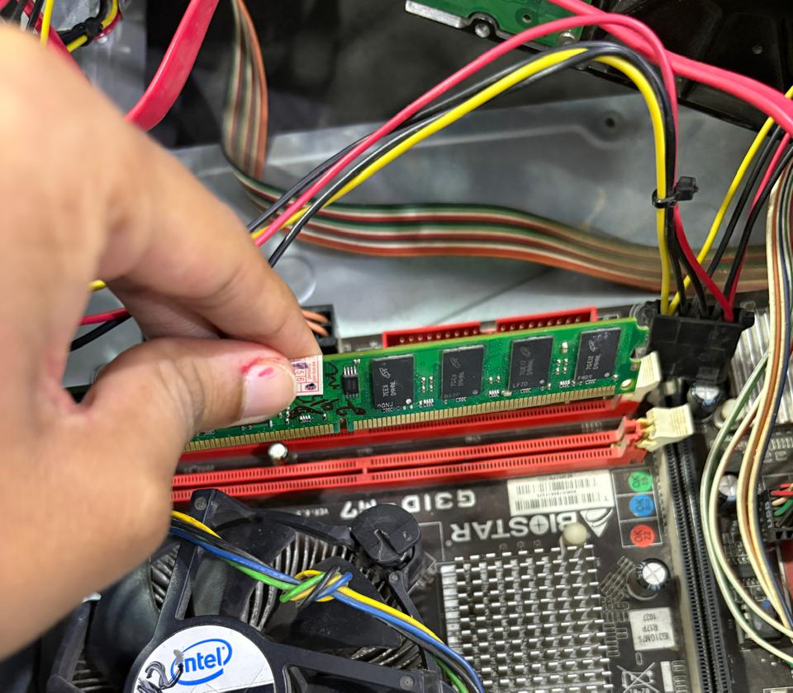
RAM module reinstalled correctly in the RAM slot.
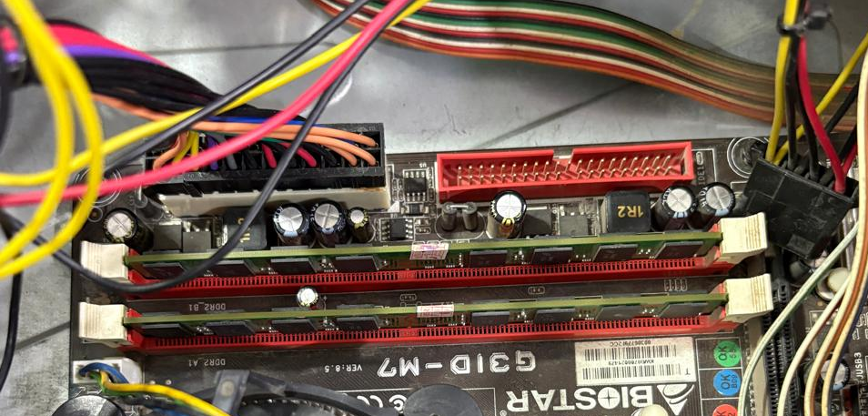

My laptop RAM
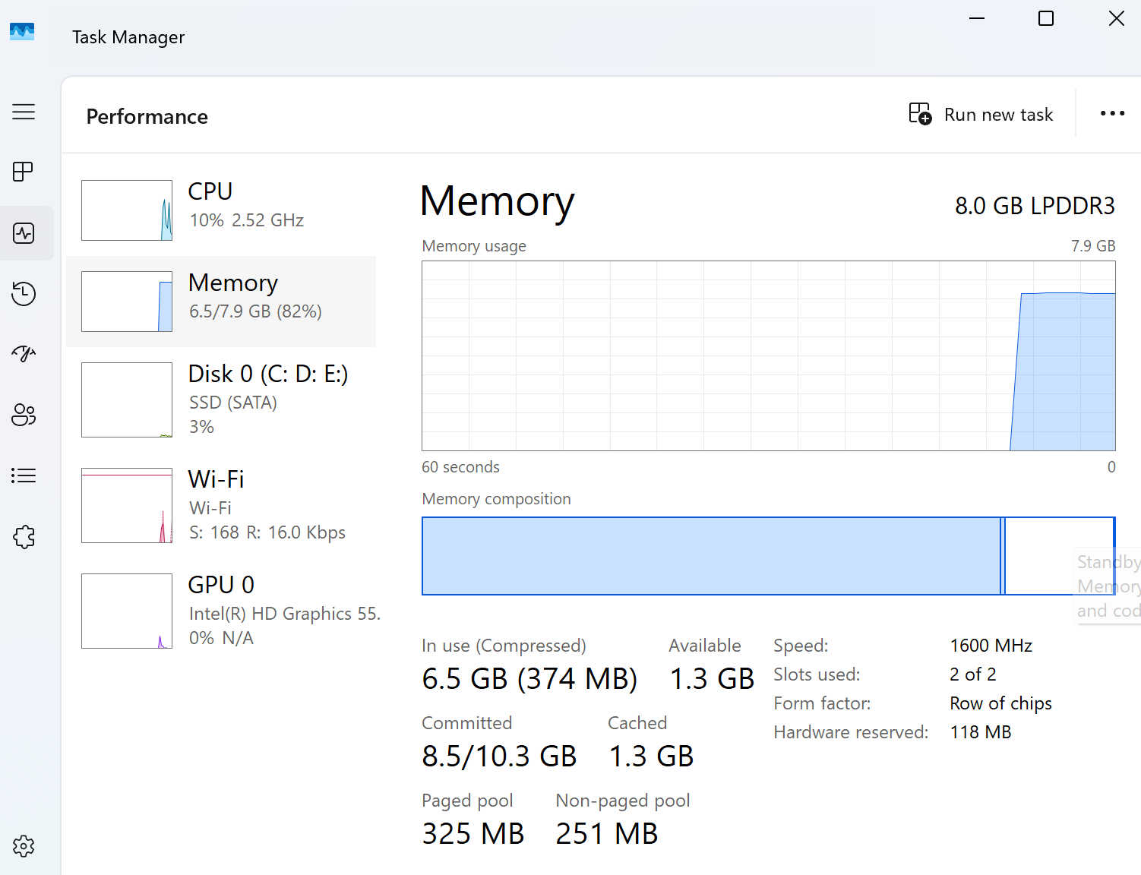

3:- Comparison of HDD, SSD, and NVMe SSD
Feature | HDD | SSD (SATA) | NVMe SSD
Full Form | Hard Disk Drive | Solid State Drive | Non-Volatile Memory Express Solid State Drive
Technology | Uses magnetic spinning platters and a read/write head | Uses NAND flash memory with no moving parts | Uses NAND flash memory with no moving parts
Speed | Slowest | Faster than HDD | Generally the fastest of the three
Typical Speed | Around 80–160 MB/s | Around 450–550 MB/s | Commonly 1,500–7,000+ MB/s, depending on generation
Connection / Interface | Usually SATA | Usually SATA | Usually PCIe using the NVMe protocol
Physical Form | Usually 2.5-inch or 3.5-inch drive | Usually 2.5-inch drive or other form factors | Commonly an M.2 stick
Moving Parts | Yes — platter and mechanical head | No | No
Noise | Can produce mechanical noise | Silent | Silent
Power Consumption | Generally higher | Lower than HDD | Generally efficient, but power varies by model
Durability | More sensitive to physical shocks because of moving parts | More resistant to shock | More resistant to shock
Cost per GB | Usually lowest | Higher than HDD | Usually higher than HDD and SATA SSD
Best Use | Large storage, backups, photos and videos | Operating system, documents and everyday applications | Gaming, video editing, large software and high-performance workloads
Daily-use example | Storing photos/videos and backups | Windows, Chrome, Microsoft Office | Large games, video editing, or transferring large files
1. Speed:
HDDs are generally the slowest because they use mechanical moving parts. SATA SSDs are much faster because they use flash memory. NVMe SSDs are generally faster than SATA SSDs because they communicate through the PCIe interface and use the NVMe protocol.
2. Technology:
HDDs store data magnetically on spinning platters. Both SATA SSDs and NVMe SSDs use NAND flash memory, so they have no moving mechanical parts.
3. Connection/interface:
HDDs and SATA SSDs commonly use the SATA interface. NVMe SSDs use PCIe, which provides much higher bandwidth.
Daily-use examples
- HDD: Useful for storing a large collection of photos, videos, movies, and backups, where very high speed is not the main requirement.
- SATA SSD: Suitable for Windows, Chrome, Microsoft Office, and everyday applications because it provides much faster boot and application loading than an HDD.
- NVMe SSD: Particularly useful for large games, video editing, 3D applications, and large file transfers, where high storage performance can reduce loading and transfer times.

4:- Remove the storage drive (HDD or SSD) from your system, take a photo of the connector type (SATA, M.2, or NVMe), and reinstall the drive. Confirm that your device recognizes the storage after reassembly.<br><br><em><strong>Constraint:</strong> Only perform this task if you have access to a device you are allowed to open. If not, find and share a YouTube video link showing the process for your laptop/PC model.</em>
The HDD was removed from the desktop system.
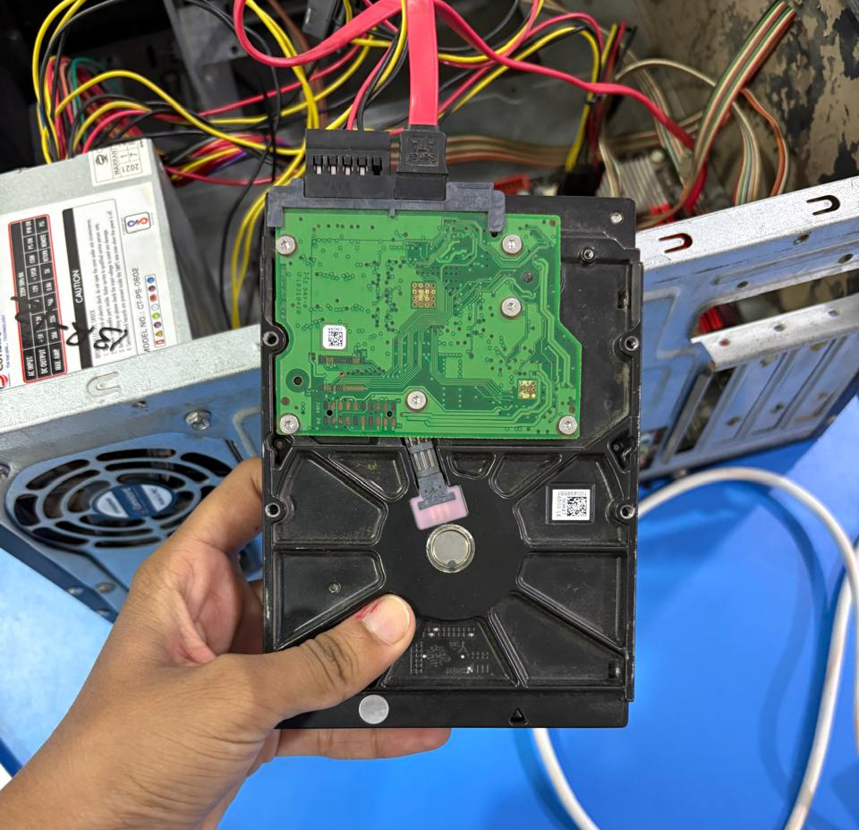

The HDD uses a SATA connector for data transfer and a separate SATA power connection.
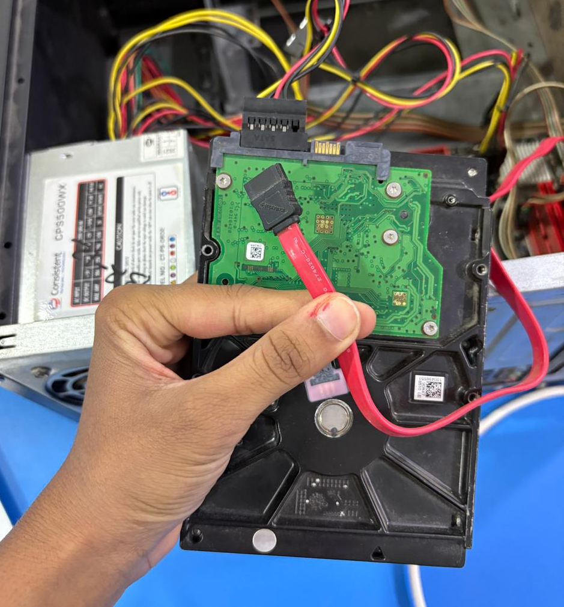
The HDD was reinstalled and the SATA data and power cables were reconnected.
